HONG KONG INSTITUTE OF VOCATIONAL EDUCATION (TY) DEPARTMENT OF INFORMATION TECHNOLOGY HIGHER DIPLOMA IN SOFTWARE ENGINEERING (IT114105)

Human Computer Interaction & GUI Programming Engineering

Module Code: ITP4506

|  |  |  |  |
| --- | --- | --- | --- |
| **Student ID** | **Name** | **Contribution** | **Signature** |
| 140170386 | Leung Hoi Wah | 25% |  |
| 140377489 | Wong Pui Ho | 25% |  |
| 140501493 | Cheung Ming Wai | 25% |  |
| 140283608 | Lam Kwan Hung | 25% |  |

Content

Abstract 3

User Characteristic 4

Techniques for observing and listening to users 6

Environment Analysis 10

Recruiting Users 10

Task Analysis (HTA) 11

Web Design Concepts 14

Conclusion 18

Abstract

This report is mainly to help us design the site. We want to understand the needs of users and their requirements through our observation and collect information. We hop through in-depth understanding, to design a perfect website.

User Characteristic

Learning style

User Habit:

Users are accustomed to find important information, such as the type of aircraft, the hotel environment and services, etc.

Tool preferences

Most of the users have knowledge of use of the website

They prefer to use selective project features, such as radio button, dropdown list, etc.

Physical differences

* Age

Most users tend to age adults, so we mainly use medium-shape, so that the user easy to read

* Sex

Through the survey that most visitors are females, so we will use simple, avoiding too complicated, leading to user confusion

* Vision limitations

Our website uses pastel colors to make the whole site more attractive, because users will be annoyed by too colorful. We will use the short text and site, to avoid too much text make difficult to read

* Easy Control

So most of our website to input the information will be use selection button or drop down list, to reduce too much text input

Cultural differences

* Education and Profession

Text is clear and simple, even though the target is children also can read and use. Websites mainly in English, which is the common language of the world, reducing user communication barriers

Knowledge of job

Is your site used daily on the job, or it is used at home for recreation or a hobby?

This is a people who like to travel to the design of the site, the inside pages of rich content. Users visit every day will not feel bored

Is there a specialized vocabulary?

he Site may contain some professional vocabulary, the user who like to travel will not feel difficult to read

Does your user do the same job all day? Bored?

Unless the user is often traveling, otherwise user will not feel bored on our website

If for public use, what is the purpose?

The purpose of this Website is hoping to provide a wide range of travel information to users to facilitate their reading relevant information. We hope our website make them have great preparation before traveling.

Application familiarity

Whether you are a novice or a professional traveler, on this website you will not feel hard to use

Primary and secondary users

* primary user: the person who actively uses the site:
  + Traveler

Techniques for observing and listening to users

Think aloud: talk while doing the job

* Ask users to say what come to their mind as they travel
* By listening to users think and hobby, we will be able to examine their expectations for our website
* We listening to users as they work could provide enormous amount of useful information about their interest.

Observation

In order to increase understanding of users' needs. We go out travel agency to observe some travelers' needs. It can improving our website design

Mailed/Online surveys

Using questionnaires to understand the needs of users can be added. In order to make our site can be more considerate of the needs of users

We purposely use guest questionnaire-based preferences, which will help us in the design of the page. Consider the needs of users, so that the entire web page more user friendly.

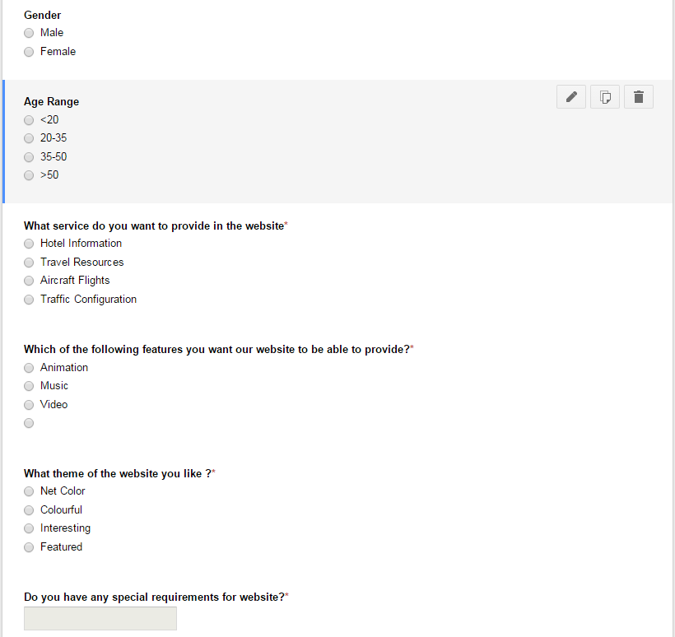

Website Reference

In order to make our website more excellent, we can refer to the site as a reference design part

Expedia

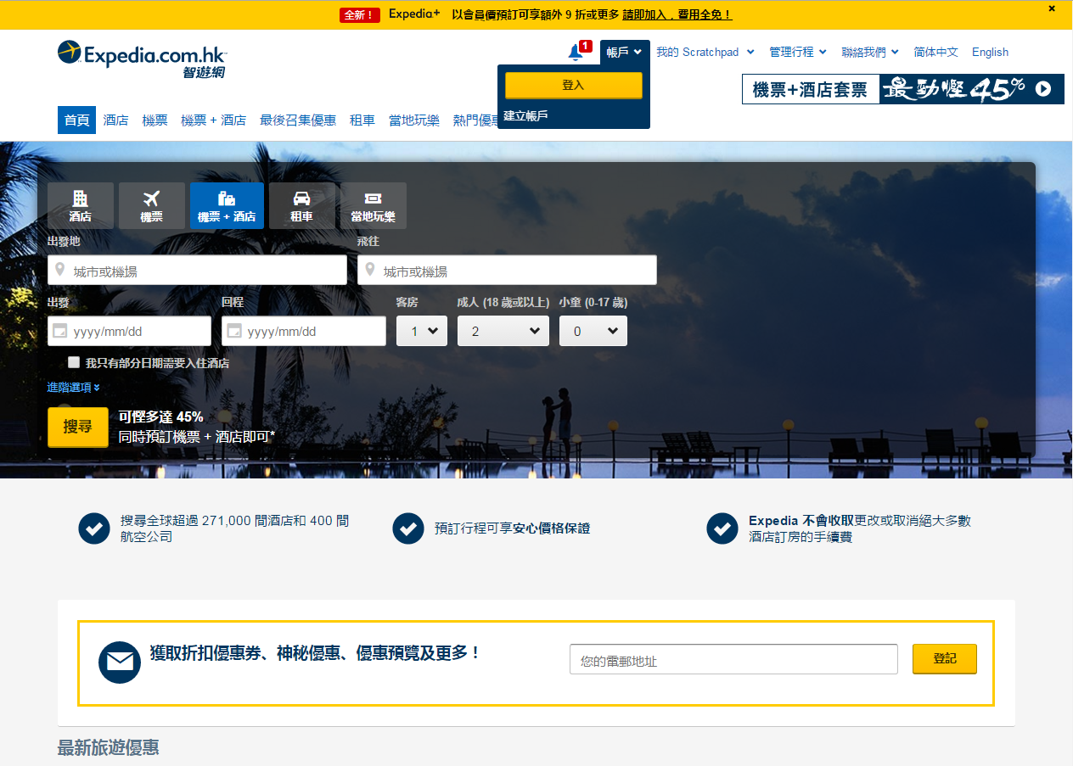

Ezfly

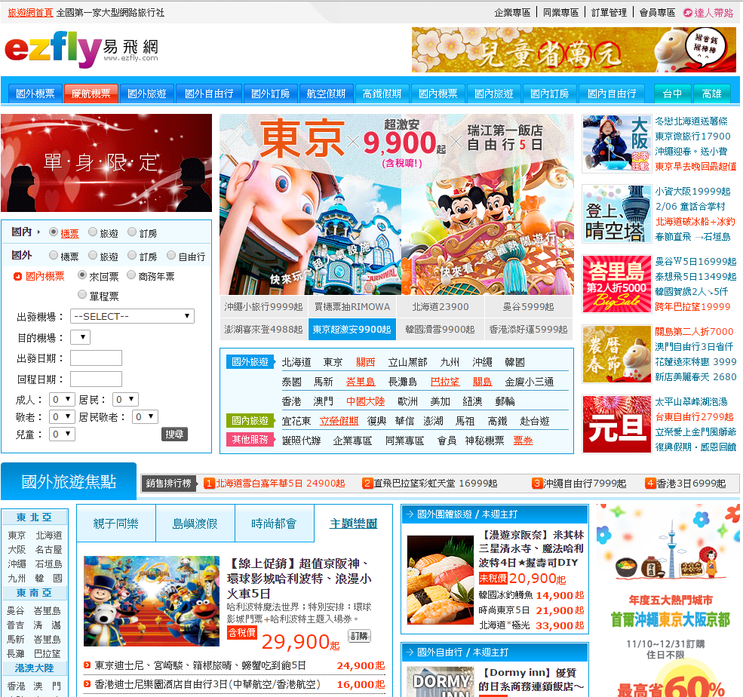

Environment Analysis

Where do people use our interface? Many variations:

* The person browse travel information at home
* Some young people who like anywhere to understand tourist information
* The person who prepare to travel abroad

Observe your users in their own setting

* Most of them prefer to browse detailed travel information at home. In addition the website features easy to use, it provides a wealth of more information. Avoid going travel agency to listen to the relevant information

Recruiting Users

We spend our time voicing the needs of our users. Consequently, it’s all too easy to fall into the trap of thinking we know what our users need without bothering to ask them.

We believe a new feature is of value to our user. However, without understanding the effect this new feature will have on the overall usability of the website, there is a risk of ‘improvement’ be in fact the reverse.

If website is in use, test with real current users:

* Traveler

Post notice on Facebook and on our company notice board to help us to announce.

Provide incentives:

* Travel accessories e.g. : Eye masks
* Payment discount

Task Analysis (HTA)

Aim: Facilitate mapping the demands of operations (i.e. tasks) and system onto people.

Goals

* Do the hotel or flight booking

Tasks

* See the hotel or flight information

Actions

* Do registration for login

Why is seeing information a task, but doing login an action?

* Because at this level of granularity, doing login cannot be broken down into smaller components
* But if you are doing login at a self-service station, and you’ve never done it before, and the instructions are hopeless, for you that’s a task

The goal/task/action distinction is useful, but should not be applied rigidly

It is important not to focus on superficial activities:

* What are people trying to achieve?
  + Do the hotel or flight booking
* Why are they trying to achieve it?
  + They need to travel to other country
* How are they going about it?
  + Do the registration to do the login name and password. Then they can login to do the booking

Hierarchical Task Analysis

1. In order to do the booking
   1. Go in the website
   2. Do registration
   3. Login
   4. View/Search flight information
   5. Access flight company name
   6. Access flight date/time
   7. Access flight location
   8. Access the search screen
   9. Click the flight details
   10. Select the ticket of first or business
   11. Enter the quantity
   12. Enter add to the shopping cart
   13. View/Search hotels information
   14. Access hotels company name
   15. Access hotels address
   16. Access hotels room price
   17. Access the search screen
   18. Click the hotels details
   19. Select the hotel room
   20. Enter the quantity
   21. Enter add to the shopping cart
   22. Go to checkout
   23. Enter personal information
   24. Select payment
   25. Confirm order

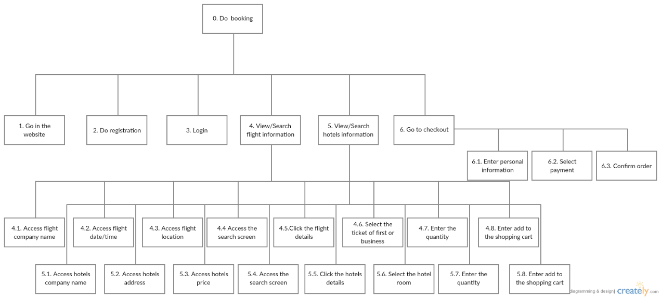

Plan 0:

Do 1-3-4-5-6.

If do not register yet, do 1-2-3-4-5-6.

If do not need flight ticket, do 1-3-5-6.

If do not need hotel room, do 1-3-4-6.

Plan 4:

Do 4.5-4.6-4.7-4.8.

If click the flight company name, do 4.1-4.4-4.5-4.6-4.7-4.8.

If click the flight date/time, do 4.2-4.4-4.5-4.6-4.7-4.8.

If click the flight location, do 4.3-4.4-4.5-4.6-4.7-4.8.

Plan 5:

Do 5.5-5.6-5.7-5.8.

If click the hotel company name, do 5.1-5.4-5.5-5.6-5.7-5.8.

If click the hotel address, do 5.2-5.4-5.5-5.6-5.7-5.8.

If click the hotel room price, do 5.3-5.5-4.5-5.6-5.7-5.8.

Plan 6:

Do 6.1-6.2-6.3.

Web Design Concepts

|  |  |
| --- | --- |
| Design Principles | Description |
| Mental Model | The users’ mental models are knew through user testing.  Do booking : login, view information, add to cart, confirm |
| Affordance | The functions or services that an interface provides.  Login affords to the booking |
| Content Organization | Organizational schemes:   * We use task-oriented     Organizational structures:   * Hierarchy: structure by rank or level * Hypertext: ad-hoc links from texts * Database: organized into tables according to attributes     Research and interview techniques:  Card sorting is an interviewing technique that will help an HCI practitioner choose an appropriate information architecture for a Web site:   * Devise a list of about 40 questions that a user might have * Write each question on a card; number cards on back * Ask each user to sort the cards into piles, where the cards in each pile seem related to each other * Ask the user to give a name to each pile * Do this with ten or more users * Do statistical analysis of the clustering in the groups |
| Visual Organization | Proximity: Sensible groups    Alignment: align top of 10px div, table width='100%', center-align each column      Consistency: Consistent layout in the next few slides   * Picture same as Alignment   Contrast: make pages more interesting  The picture can move |

|  |  |
| --- | --- |
| Navigation | Navigation Bars    Pull-down Menus    Frames    Table of Contents    Site Map  A site map's main benefit is to give users an overview of the site's areas in a single glance   * BestTrip Travel - Home   - Flight information  - Hotel information  - Checkout - Order  - Shopping cart  - Flight information  - Login  - Register |

# Conclusion

In conclusion, this report has include the User Analysis and Web Design Concepts. This identify the users of your system and describe how we employ the web design concepts learned in the module and help us to move on to design the website.